The Membership Speaks: The Curriculum Implementation Survey
The BCTF has published the results of the Curriculum Implementation Survey. The survey was completed by teachers from 57 districts from around the province and 4% of respondents came from Burnaby (only Surrey and Vancouver contributed more). 80% of teachers surveyed were classroom teachers and 87% taught K-9.
The survey examined four key areas: teachers attitudes towards the curricular model itself, its impact on teacher autonomy and workload, teacher involvement, professional development and learning, and finally the implementation process itself.
Curricular Model:
Regarding the curricular model, most teachers felt somewhat comfortable with their ability to teach the Core Competencies. Teachers were on surer footing when it came to the literacy and numeracy foundations with 76% of teachers reporting they were either “very” or “somewhat” ready to teach them.

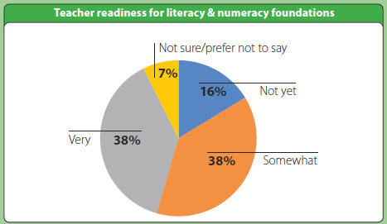
Teachers were less comfortable with the prospect of using “Information and Communication Technology (ICT) enabled learning environments” with 52% of respondents claiming that they did not feel ready to incorporate them into their pedagogical practice and decisions.
And when it comes to integrating Aboriginal perspectives in the classroom, approximately 3 out of 4 teachers (76%) say that they do not have sufficient access to the necessary instructional materials.
Teacher Autonomy and Workload:
The results were very positive regarding teacher autonomy with the overwhelming majority reporting the new curriculum allowed them the freedom to teach what and how they wanted. A full 79% reported they could use their choice of assessment practices.
The picture was less rosy when it came to teacher workload with many members reporting that the redesigned curriculum either moderately or significantly increased their workload. The causes of the increases?
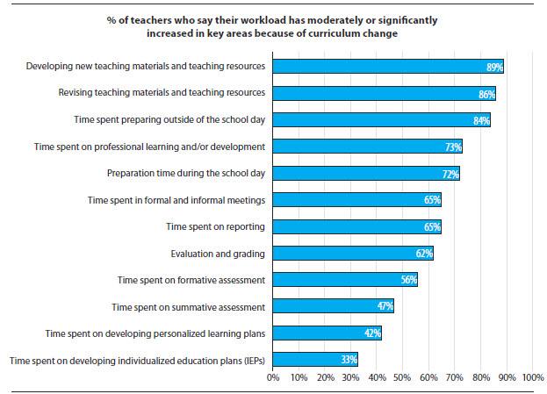

Teacher Involvement, Professional Development and Learning:
Teachers were involved in the process with approximately three out of five teachers have participating in formal structures related to curriculum change. However, many felt that they didn’t have a “meaningful voice” at the district or even at the school level. The majority of respondents reported they had no or moderate influence.
Teachers also reported that they felt there were a lack of opportunities for professional development related to the new curriculum. This meant that teachers were left on their own to learn more about the curriculum contributing to the increases in teacher workload noted above.
Implementation:
In the big picture, teachers were largely supportive of the new curriculum with 55% of K-9 teachers either “Fully Supportive” or “Supportive” of it and only 11% “Not at all Supportive” of the change. For many teachers, the new curriculum better aligns with their own philosophy of education. They highlight the increased flexibility the curriculum provides and how this allows for more student-centered learning.
However, even those teachers who view the curriculum favourably expressed frustration with some aspects of implementation. These include: a lack of instructional materials, inadequate time for learning and collaboration, the need for professional development opportunities, lack of access to technology, unclear and or misaligned direction on assessment and reporting, and a rushed and frustrating implementation process.

Teachers opposed to the new curriculum expressed frustration and stress with the increased workload and the lack of resources and professional development opportunities for implementation. Some expressed skepticism about its pedagogical effectiveness and perceived a lack of rigour in the teaching of literacy and numeracy. Some indicated that they felt flexibility might result in a loss of social cohesion that comes from shared “common knowledge”.
Overall the tone of the report was broadly positive, but teachers shared many of the same concerns that you have no doubt heard in your staffrooms. The BCTF plans to continue to monitor the implementation process in the coming years and communicate teachers’ concerns and recommendations to the Ministry of Education. To see the full report for yourself visit https://bctf.ca/CurriculumSurvey/

