Idle Worship: How Smartphones are Changing Children
According to media critic and educator John M. Culkin, “We shape our tools and, thereafter, our tools shape us.” The internet is perhaps the most powerful tool ever invented so it is hardly surprising it is now having a powerful effect on how we live our lives. Our connectivity has changed the way we get our information and entertainment. It has changed how we teach, how we shop and how we practice our politics. Now pediatricians, psychologists and educators are examining a growing body of research that suggests that it is changing our students as well.
The Growing Up Digital project was created through a partnership between the Alberta Teachers Association, the University of Alberta as well as Boston Children's’ Hospital and Harvard Medical school. A random province-wide survey of a little over 2200 teachers was conducted during the 2015/16 school year. Its findings showed both the promise and the peril of digital technologies.
On the one hand, teachers indicated that they felt using digital technologies enhanced student learning with 71% of respondents indicating that they facilitated inquiry-based learning opportunities. 79% of teachers surveyed indicated they believed incorporating technology gave students access to an increased variety of resources which allowed teachers to better differentiate instruction. They also suggested technology greatly facilitated parent-teacher communication. All good things.
However, when surveyed on issues related to health and well-being outcomes, Alberta teachers indicated that there has been a dramatic change in their student populations over the past 3 to 5 years. Of particular note is the “somewhat” and “significant” increase in the number of students who demonstrate emotional challenges such as anxiety and depression (90%) as well as social challenges (86%).
This mirrors the findings of Dr. Jean Twenge a Professor of Psychology at San Diego State University and author of iGen. Using data collected from over 11 million American students she has found that the generation growing up after the invention of the smartphone is unhappier and more isolated than any who have come before.

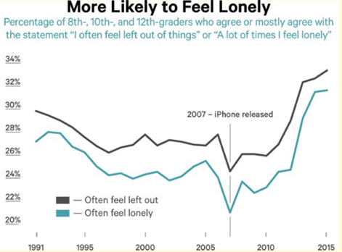

And while there are many potential causes to the rising tide of emotional challenges such as anxiety and depression, she finds a strong correlation between screen time and unhappiness concluding, “There’s not a single exception. The more time teens spend looking at screens, the more likely they are to report symptoms of depression”.
Subsequent studies investigated the link further specifically examining whether social media led to unhappiness or whether unhappiness led to social media. The evidence pointed overwhelmingly to the former. A particularly troubling finding in light of the Global Web Index which reports that in 2016 internet users spent an average of over two hours per day on social media and messaging services, the fourth straight year the average has increased.
Beyond the emotional toll, students’ physical well-being is also being affected by excessive screen time. Two thirds of Alberta teachers reported that students are coming to school tired. The teachers aren’t imagining things. Dr. Twenge’s research found that the percentage of high-school students who get less than 7 hours of sleep per night has increased from 34% in 2007 when the first iPhone was released to 41% in 2015.
This change isn’t healthy. Using data collected by the Adolescent Brain Cognitive Development (ABCD) Study, Dr. Jeremy Walsh of the Children's’ Hospital of Eastern Ontario Research Institute in Ottawa warns “"The shift in the lifestyle behaviours of children towards low physical activity, a reduction in sleep and ubiquitous screen time use may pose a threat to cognitive development." This, too, has already been observed by Alberta teachers with 77% reporting they have witnessed an increase in the number of students suffering cognitive challenges.
Another finding? 3 out of 4 Alberta teachers believe their students’ ability to focus on educational tasks has decreased. This is predictable according to Dr. Paul Mohapel of Royal Roads University in Victoria who writes increased distraction is a common impairment of technology usage. Multitasking online can lead to “continuous partial attention,” a pathological state of inattention to any given task. Research has shown that mentally switching tasks decreases your brain’s processing efficiency by half. Technology is impairing not only our ability to pay attention, but to learn. He claims multitasking over-stimulates and burns out the prefrontal cortex, the regions of the brain responsible for directing attention. This prevents our ability to access memories and learn new things.
It has been only 12 years since the invention of the first smart phone and only 15 since the first social networking appeared online. It is not surprising that we are only now beginning to appreciate their full impact. We owe it to students, their parents, and ourselves to critically examine both the risks and rewards of digital technologies. In our desire to adopt innovative teaching strategies and engage our students with new technologies, we cannot take it on faith that every innovation is an improvement.

